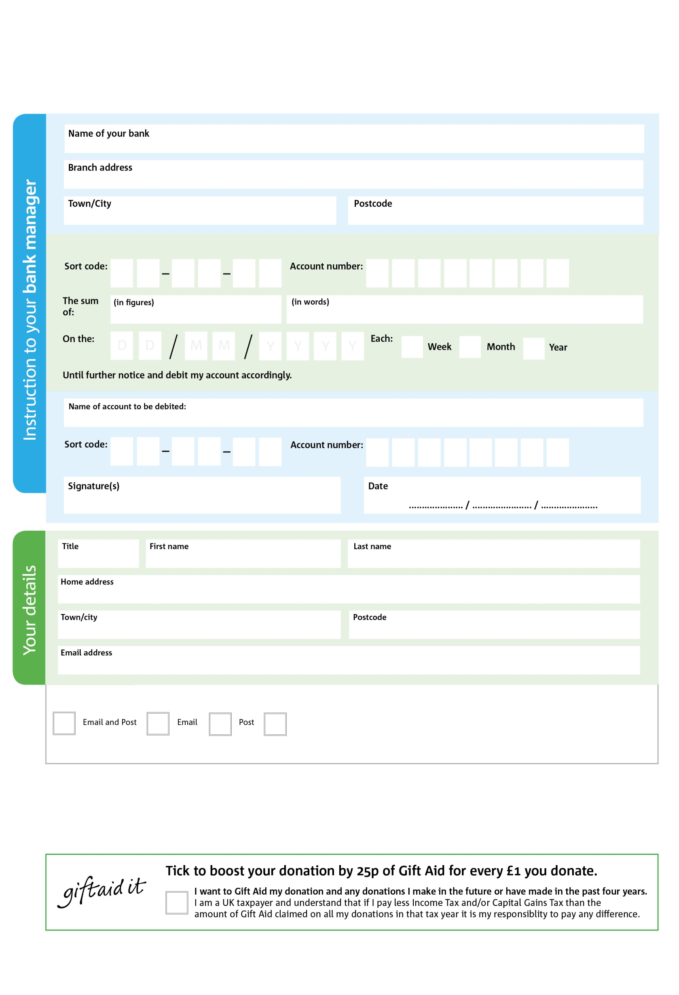

I do not wish to receive future communications from Horsham Matters

You can change your preferences any time by contacting us on 0300 1240204 or emailing us at info@horsham-matters.org.uk

**Please pass this form onto the Horsham Matters, using theat the bottom, who will save a copy for their records.   
They will then send it onto your named bank or building society.**

Reg. Charity No: 1116253 | Reg. in England & Wales

4000X

**Standing Order Mandate**

**Info@horsham-matters.org.uk**

Please pay Horsham Matters/District Foodbank

POSTAL ADDRESS: Horsham Matters, Micah House, Blatchford Road, Horsham RH13 5QR

2

V

7

V

4

V

1

V

2

V

000

V

00

V

0

V

0

40

2

5

0X

We would love to keep you up to date with information about Horsham Matters. Please tick your preference:

**Data protection**

*Horsham Matters is committed to protecting your privacy and will process your personal data in accordance with current Data Protection legislation. Horsham Matters collects information to keep in touch with you and supply you with information relating to our work. To unsubscribe from our newsletter, send a message to the email address above with the word unsubscribe in the subject line. A full data privacy statement for financial donors is available from the office on request.’*

You can change your preferences any time by contacting us on XXXXXXXXXXX or emailing us at XXXX@XXXXXXXXXX.foodbank.org.uk

I do not wish to receive future communications from XXXXXX Foodbank